

**RAMAIAH INSTITUTE OF TECHNOLOGY, BANGALORE-560054**

**(Autonomous Institute, Affiliated to VTU)**

**Department of Computer Science & Engineering**

**Internship Report**

**on**

**Mobile Application Development**

**INT410: Intra Institutional Internship**

**STUDENT NAME : Surya A**

**USN : 1MS23IS131**

**Ramaiah Institute of Technology**

**(Autonomous Institute, Affiliated to VTU)**

**MSR Nagar, MSRIT Post, Bangalore-560054**

**August - 2024**



**RAMAIAH INSTITUTE OF TECHNOLOGY, BANGALORE-560054**

**(Autonomous Institute, Affiliated to VTU)**

**Department of Computer Science & Engineering**

**CERTIFICATE**

This is to certify that Mr./Ms. ______________________________________________________, a student of Bachelor of Engineering, bearing USN: ______________________, has successfully completed, 20 Hours: from 06.08.2024 to 14.08.2024 Intra Institutional Internship in Mobile Application Development from the Department of Computer Science & Engineering, M S Ramaiah Institute of Technology, Bangalore.

| **SL.**  **NO** | **Component** | **Maximum Marks** | **Marks obtained** |
| --- | --- | --- | --- |
| **1** | **Continuous Evaluation** | **50** |  |
| **2** | **Presentation** | **20** |  |
| **3** | **Report** | **30** |  |
| **Total Marks** | | **100** |  |

**Signature of the Student with Date Signature of Faculty Co-Ordinator**

**Signature of Head of Department**

| **OVERVIEW OF INTERNSHIP ACTIVITIES**       | **DATE** | **DAY** | **NAME OF THE TOPIC COMPLETED** | | --- | --- | --- | | **07/08/24** | **Wednesday** | **Flutter app and basics of dartcode** | | **09/08/24** | **Friday** | **Dartpad and executions of basic programs** | | **12/08/24** | **Monday** | **Widgets,Scaffold,Appbar and other components** | | **14/08/24** | **Wednesday** | **Implementation and test** | |  |  |  | |  |  |  | |  |
| --- | --- | --- | --- | --- | --- | --- | --- | --- | --- | --- | --- | --- | --- | --- | --- | --- | --- | --- | --- | --- | --- | --- |
|  | |

**TABLE OF CONTENTS**

**Contents Page No.**

**1. Pokedex**  ………………………………………………………………………..  **5**

**1.1 What is it?** …………………………………………………………………  **5**

**1.2 The features of it** ………………………………………………………….. **5**

**2. Usage of mobile app development** ……………………………………………….  **5**

**2.1 Flutter** ……………………………………………………………………… **5**

**2.2 Dartpad** …………………………………………………………………….  **5**

**2.3 Github**  ………………………………………………………………………  **6**

**3. Code of the program** ……………………………………………………………. **6**

**4. Result Snapshots**  ………………………………………………………………… **14**

**5. Conclusion**  ………………………………………………………………………..  **20**

**1.Pokedex**

**1.1 What is it?**

**Pokemon is the biggest grossing franchise of all time with an estimated value of 100 billion dollars.With over 90 billion made from the merchandise alone.Sufficient to say the “pokemon” are only the brand and its name-sake,but also the reach for its popularity and commercial success .**

**In the shows or games or any media relating to pokemon , they are always depicted in an ordered list where their features and quirks can be read. This thing is called a “pokedex”.**

**1.2 The features of it**

**There are several thing mentioned about the pokemon but namely -**

* **The unique number assigned to them for ordering in the pokedex.**
* **The name and its type(s).**
* **The height ,weight and gender ratio.**
* **Its category and abilities.**
* **Finally it's statistics and weaknesses.**

**2.Usage of mobile app development**

**2.1 Flutter and Android studio**

**In our internship we have learned the basics of flutter and how to use it on pc.**

**Though we learnt how to operate in ubuntu(linux), it can be used on other operating systems as well such as windows.**

**Flutter can be developed for any system depending on the designers wishes, that is IOS or Android.We also learnt that flutter runs on dart code which is a combination of many other programming languages like python,c,c++,java,etc…**

**2.2 Dartpad**

**Dartpad is an online compiler that uses dart code .Dartpad was a crucial asset in this project as it let us explore and ideate without much consequence.**

**This is because not having to download assets and programs while we were still figuring out how to operate in dart code was a huge help .**

**2.3 Github**

**We were encouraged to create a github account as github is a service where programmers can store,download and upload software.**

**This was a huge help to us in particular as we used sprites done by a collaborative effort of “Lati111” ,”Narmasim” and many others .**

**Link to their work -** [**https://github.com/PokeAPI/sprites**](https://github.com/PokeAPI/sprites)

**3.Code of the program**

**import 'package:flutter/material.dart';**

**void main() {**

**runApp(PokedexApp());**

**}**

**class PokedexApp extends StatelessWidget {**

**@override**

**Widget build(BuildContext context) {**

**return MaterialApp(**

**title: 'Pokédex',**

**home: PokemonListScreen(),**

**debugShowCheckedModeBanner: false,**

**);**

**}**

**}**

**class Pokemon {**

**final int id;**

**final String name;**

**final String type;**

**final String imageUrl;**

**Pokemon({**

**required this.id,**

**required this.name,**

**required this.type,**

**required this.imageUrl,**

**});**

**}**

**final List<Pokemon> pokedex = [**

**Pokemon(**

**id: 1,**

**name: 'Bulbasaur',**

**type: 'Grass/Poison',**

**imageUrl: 'https://raw.githubusercontent.com/PokeAPI/sprites/master/sprites/pokemon/1.png',**

**),**

**Pokemon(**

**id: 2,**

**name: 'Ivysaur',**

**type: 'Grass/Poison',**

**imageUrl: 'https://raw.githubusercontent.com/PokeAPI/sprites/master/sprites/pokemon/2.png',**

**),**

**Pokemon(**

**id: 3,**

**name: 'Venusaur',**

**type: 'Grass/Poison',**

**imageUrl: 'https://raw.githubusercontent.com/PokeAPI/sprites/master/sprites/pokemon/3.png',**

**),**

**Pokemon(**

**id: 4,**

**name: 'Charmander',**

**type: 'Fire',**

**imageUrl: 'https://raw.githubusercontent.com/PokeAPI/sprites/master/sprites/pokemon/4.png',**

**),**

**Pokemon(**

**id: 5,**

**name: 'Charmeleon',**

**type: 'Fire',**

**imageUrl: 'https://raw.githubusercontent.com/PokeAPI/sprites/master/sprites/pokemon/5.png',**

**),**

**Pokemon(**

**id: 6,**

**name: 'Charizard',**

**type: 'Fire/Flying',**

**imageUrl: 'https://raw.githubusercontent.com/PokeAPI/sprites/master/sprites/pokemon/6.png',**

**),**

**Pokemon(**

**id: 7,**

**name: 'Squirtle',**

**type: 'Water',**

**imageUrl: 'https://raw.githubusercontent.com/PokeAPI/sprites/master/sprites/pokemon/7.png',**

**),**

**Pokemon(**

**id: 8,**

**name: 'Wartortle',**

**type: 'Water',**

**imageUrl: 'https://raw.githubusercontent.com/PokeAPI/sprites/master/sprites/pokemon/8.png',**

**),**

**Pokemon(**

**id: 9,**

**name: 'Blastoise',**

**type: 'Water',**

**imageUrl: 'https://raw.githubusercontent.com/PokeAPI/sprites/master/sprites/pokemon/9.png',**

**),**

**];**

**class PokemonListScreen extends StatefulWidget {**

**@override**

**_PokemonListScreenState createState() => _PokemonListScreenState();**

**}**

**class _PokemonListScreenState extends State<PokemonListScreen> {**

**TextEditingController _searchController = TextEditingController();**

**List<Pokemon> _filteredPokedex = pokedex;**

**void _filterPokemons() {**

**final query = _searchController.text;**

**setState(() {**

**_filteredPokedex = pokedex.where((pokemon) {**

**return pokemon.id.toString().contains(query);**

**}).toList();**

**});**

**}**

**@override**

**Widget build(BuildContext context) {**

**return Scaffold(**

**appBar: AppBar(**

**title: Text('Pokédex'),**

**),**

**drawer: Drawer(**

**child: ListView(**

**padding: EdgeInsets.zero,**

**children: <Widget>[**

**DrawerHeader(**

**decoration: BoxDecoration(**

**color: Colors.blue,**

**),**

**child: Text(**

**'Pokédex Menu',**

**style: TextStyle(**

**color: Colors.white,**

**fontSize: 24,**

**),**

**),**

**),**

**ListTile(**

**leading: Icon(Icons.home),**

**title: Text('Home'),**

**onTap: () {**

**Navigator.pop(context);**

**},**

**),**

**ListTile(**

**leading: Icon(Icons.search),**

**title: Text('Search Pokémon'),**

**onTap: () {**

**Navigator.pop(context);**

**},**

**),**

**ListTile(**

**leading: Icon(Icons.info),**

**title: Text('About'),**

**onTap: () {**

**Navigator.pop(context);**

**},**

**),**

**],**

**),**

**),**

**body: Padding(**

**padding: const EdgeInsets.all(8.0),**

**child: Column(**

**children: [**

**SearchBar(controller: _searchController, onChanged: _filterPokemons),**

**Expanded(**

**child: ListView.builder(**

**itemCount: _filteredPokedex.length,**

**itemBuilder: (context, index) {**

**final pokemon = _filteredPokedex[index];**

**return Card(**

**elevation: 5,**

**margin: EdgeInsets.symmetric(vertical: 8),**

**child: ListTile(**

**leading: Image.network(pokemon.imageUrl, width: 50, height: 50),**

**title: Text(pokemon.name),**

**subtitle: Text(pokemon.type),**

**trailing: IconButton(**

**icon: Icon(Icons.info),**

**onPressed: () {**

**Navigator.push(**

**context,**

**MaterialPageRoute(**

**builder: (context) => PokemonDetailScreen(pokemon: pokemon),**

**),**

**);**

**},**

**),**

**),**

**);**

**},**

**),**

**),**

**],**

**),**

**),**

**);**

**}**

**}**

**class PokemonDetailScreen extends StatelessWidget {**

**final Pokemon pokemon;**

**PokemonDetailScreen({required this.pokemon});**

**@override**

**Widget build(BuildContext context) {**

**return Scaffold(**

**appBar: AppBar(**

**title: Text(pokemon.name),**

**),**

**body: Padding(**

**padding: const EdgeInsets.all(16.0),**

**child: Column(**

**crossAxisAlignment: CrossAxisAlignment.start,**

**children: [**

**Center(**

**child: Image.network(pokemon.imageUrl, width: 150, height: 150),**

**),**

**SizedBox(height: 20),**

**Text(**

**'Name: ${pokemon.name}',**

**),**

**SizedBox(height: 10),**

**Text(**

**'Type: ${pokemon.type}',**

**),**

**SizedBox(height: 20),**

**ElevatedButton(**

**onPressed: () {**

**ScaffoldMessenger.of(context).showSnackBar(**

**SnackBar(content: Text('${pokemon.name} is a great Pokémon!')),**

**);**

**},**

**child: Text('Favorite'),**

**),**

**SizedBox(height: 20),**

**Text(**

**'More Details:',**

**),**

**SizedBox(height: 10),**

**Text(**

**'Pokémon ID: ${pokemon.id}',**

**),**

**SizedBox(height: 10),**

**Text(**

**'Image URL:',**

**),**

**SelectableText(pokemon.imageUrl),**

**],**

**),**

**),**

**);**

**}**

**}**

**class SearchBar extends StatelessWidget {**

**final TextEditingController controller;**

**final Function onChanged;**

**SearchBar({required this.controller, required this.onChanged});**

**@override**

**Widget build(BuildContext context) {**

**return Padding(**

**padding: const EdgeInsets.symmetric(vertical: 8.0),**

**child: TextField(**

**controller: controller,**

**decoration: InputDecoration(**

**border: OutlineInputBorder(),**

**labelText: 'Search by Pokémon ID',**

**prefixIcon: Icon(Icons.search),**

**),**

**onChanged: (text) {**

**onChanged();**

**},**

**),**

**);**

**}**

**}**

**4.Result Snapshots**

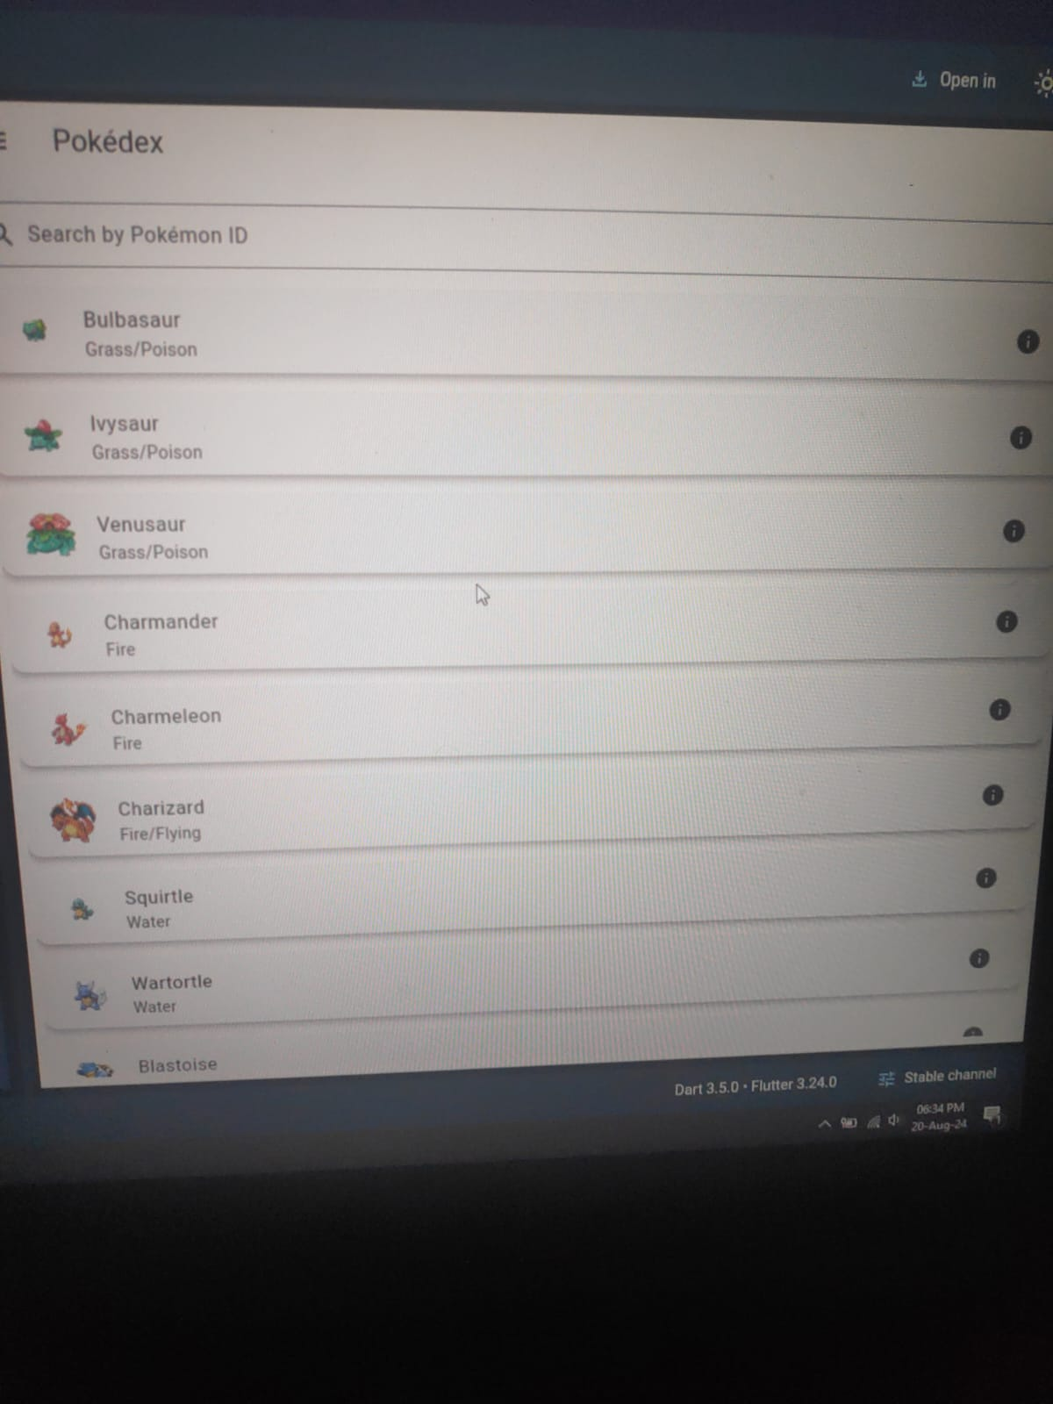

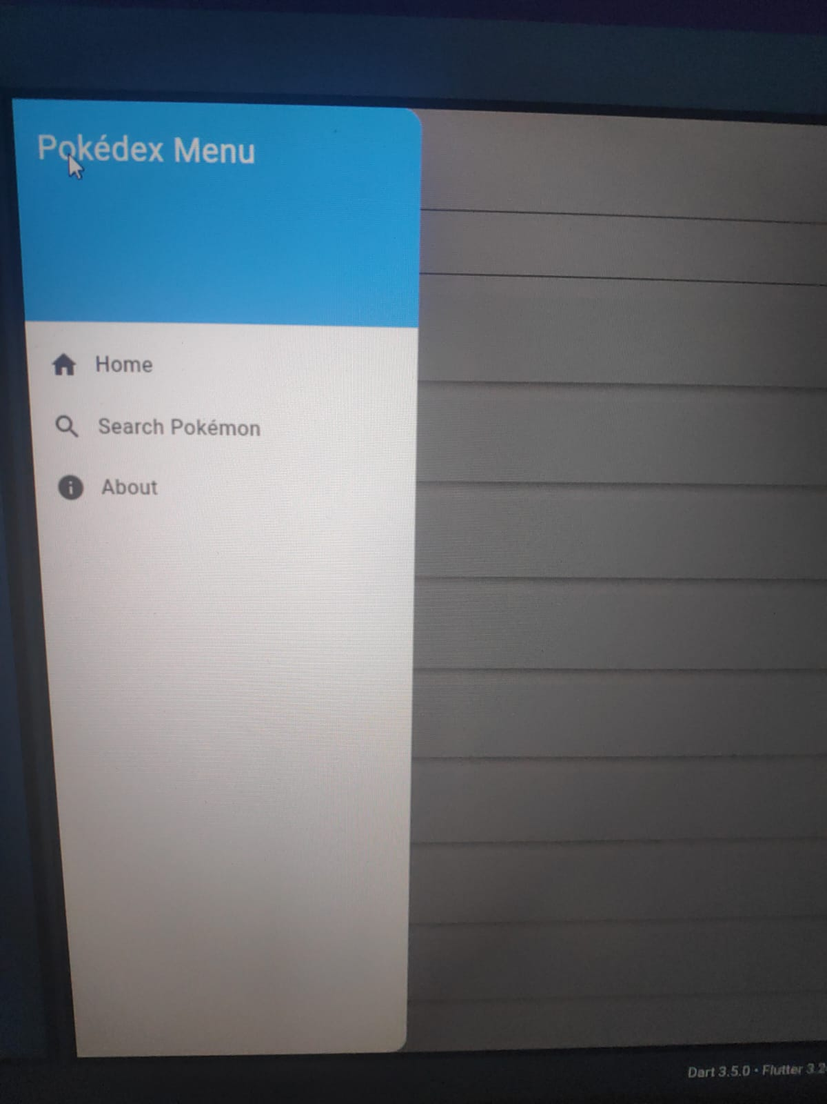

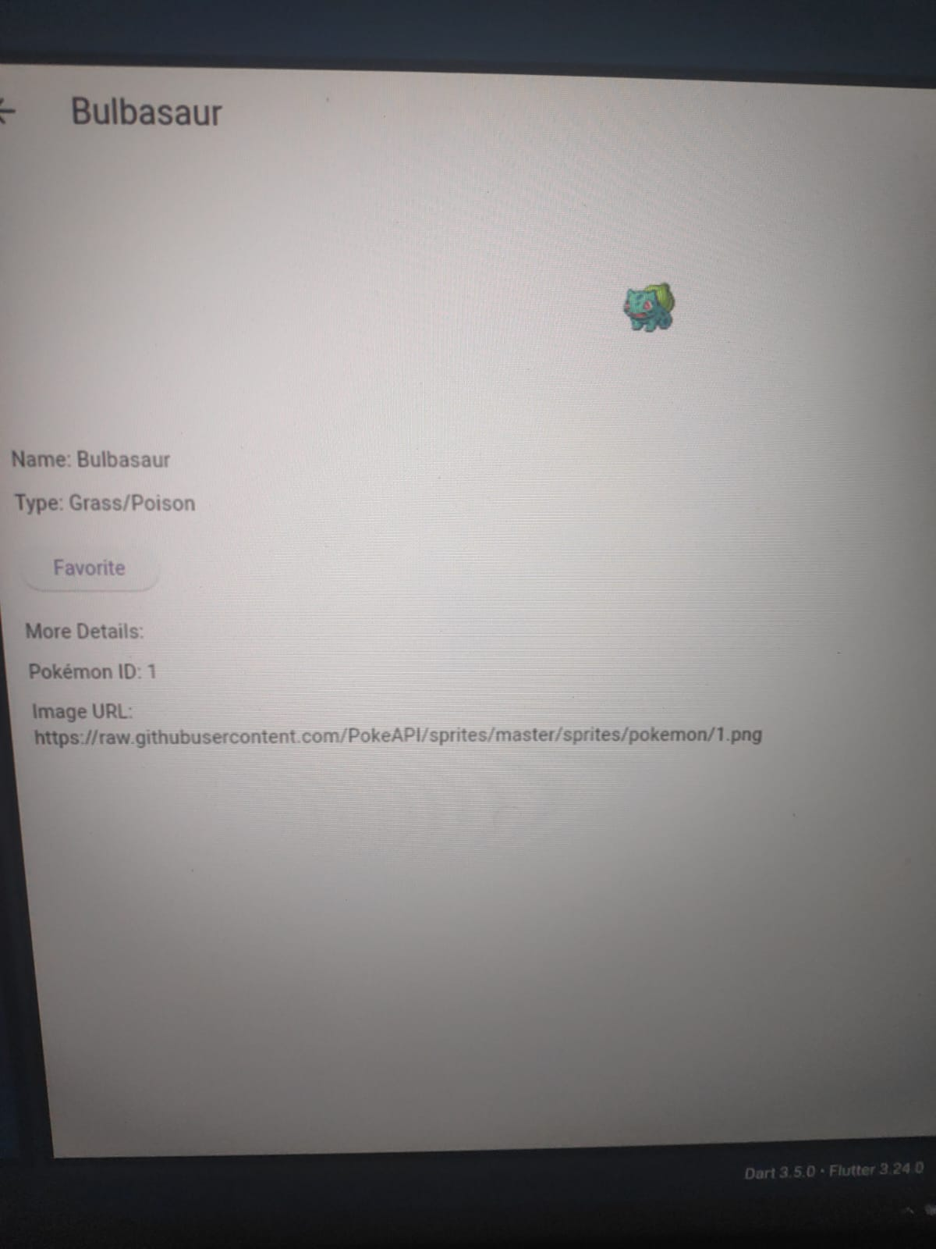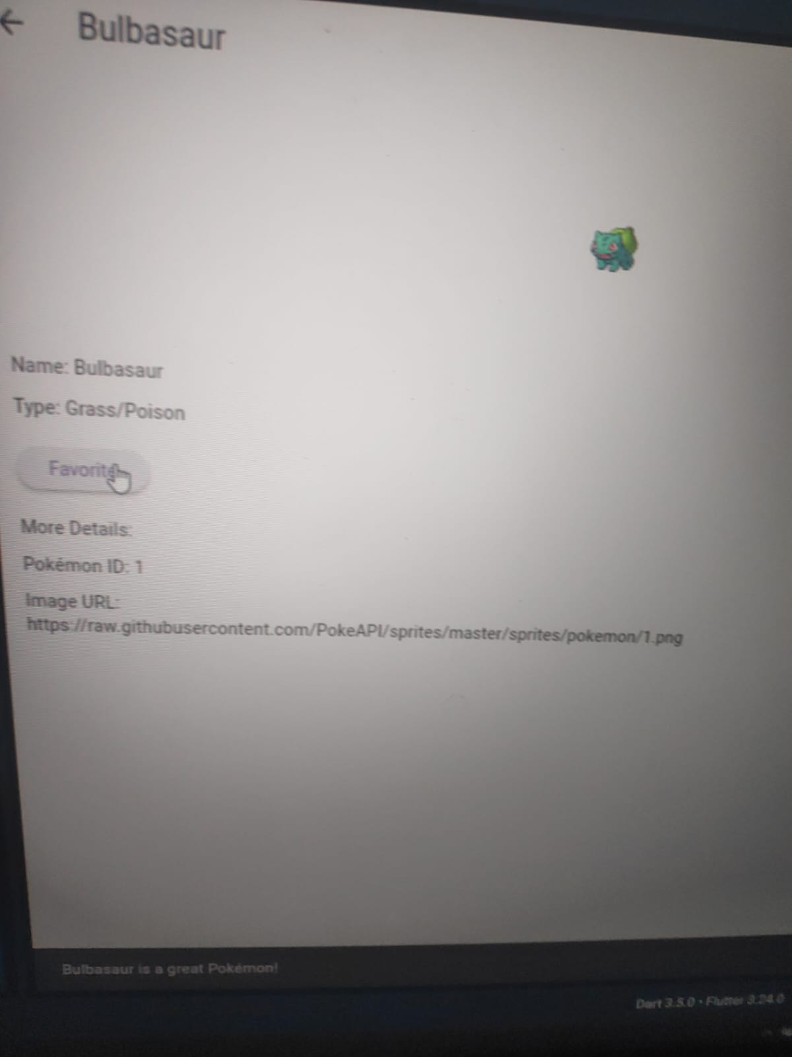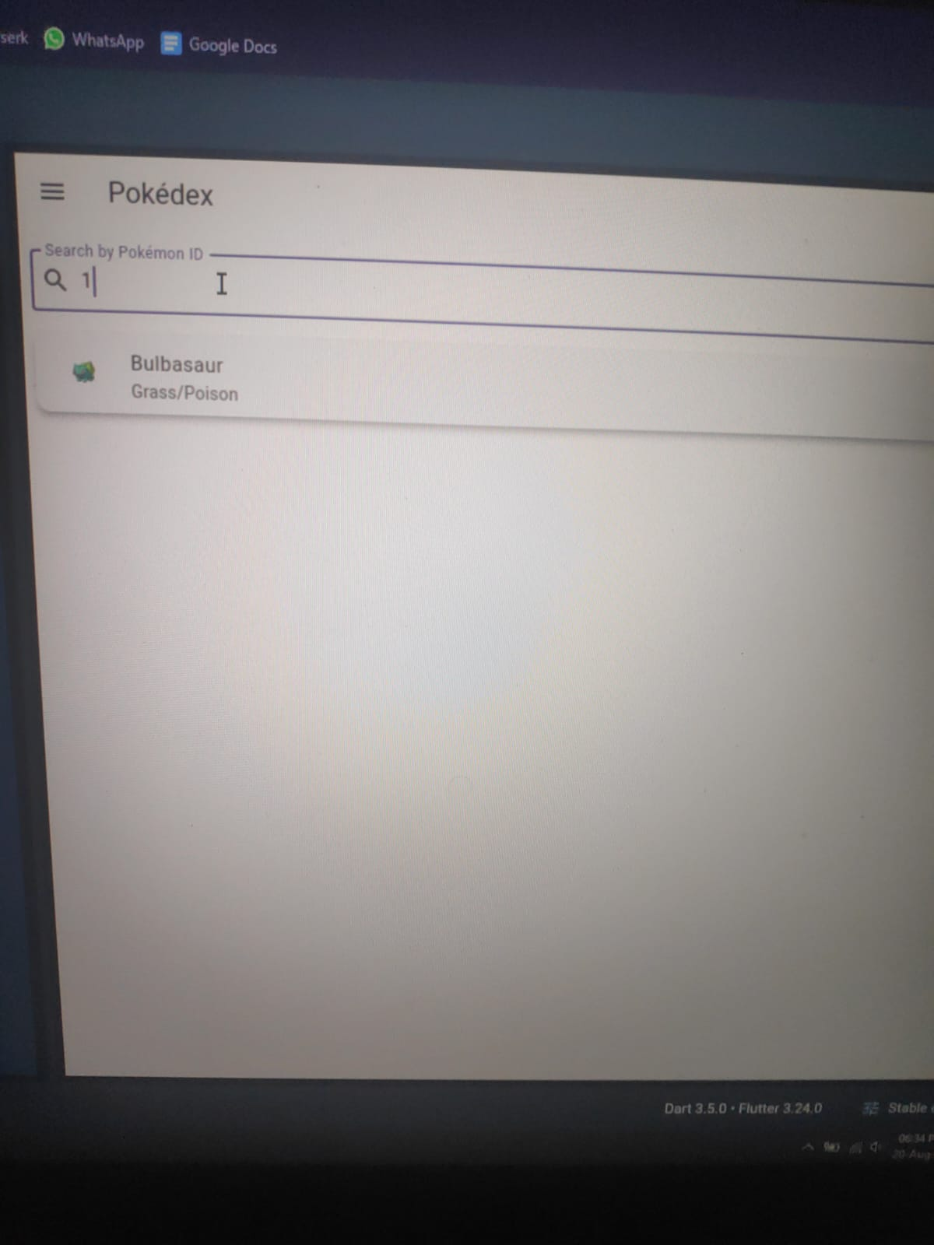

**5.Conclusion**

**We use our phones everyday but learning the ins-and-outs of how the software applications are made on mobile devices, it has brought our level of understanding and respect for mobile app developers into a whole nother level.**

**To create this basic program we required almost 300 lines of code ,we can only imagine for now how hard and interesting codes developed by hired programmers can be. And ,one day we hope to be those designers who can create suffocated apps and software .**